Annexe A :

CATALOGUE FOR GYMN EQUIPMENT

- BODY SOLID LEG PRESS HACK SQUAT MACHINE - ESTIMATED QUANTITY: 4
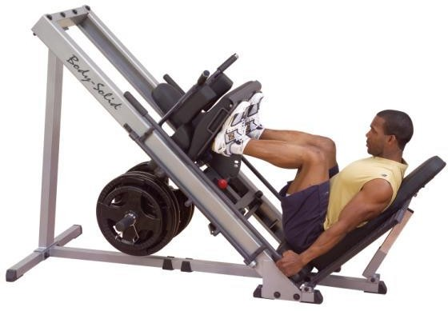 | DIMENSIONS :  210CM(L) X86CM(W) X142CM(H) SHIPPING DIMENSIONS: 79CM(L)X64CM(W)X29CM(H) - 57KG  198CM(L)X31CM(W)X12CM(H) - 40KG  140CM(L)X23CM(W)X13CM(H) - 27KG  72CM(L)X62CM(W)X12CM(H) - 24KG  85CM(L)X58CM(W)X20CM(H) - 14KG | MAIN CHARACTERISTICS:  - THE FOUR-WAY ROLLER SYSTEM OPERATES SMOOTHLY AND DISTRIBUTES THE WEIGHT EVENLY.  - BOTH REAR PADS USE A QUICK TILT AND LOCK MECHANISM.  - EXTRA-HEAVY FLAT DIAMOND FOOT PLATFORMS FOR LEG PRESS AND HACK SQUAT POSITIONS.  - EASY-TO-ACCESS PLATE LOADING SYSTEM UNDER THE TROLLEY.  - THE RUGGED 2" X 4" HIGH-CALIBRE 11 STEEL MAIN FRAME MINIMIZES TORSIONAL BENDING FOR MAXIMUM STRENGTH AND STABILITY.  - DURAFIRM ULTRA-RESISTANT A DOUBLE COUTURE  - THE BACK PADS AND SHOULDERS ARE 4 CM THICK AND PROFILES FOR MAXIMUM SUPPORT OF THE LOWER BACK AND SHOULDERS.  - THREE LOCKING POSITIONS FOR THE SAFETY AND CONVENIENCE OF THE USER.  - CAPACITY OF 1000 LBS / 453KG  - IDEAL FOR HOME AND COMMERCIAL USE.

- ADJUSTABLE BENCH – ESTIMATED QUANTITY: 7

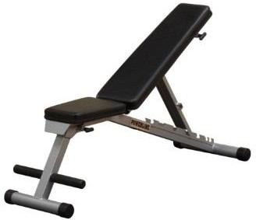 | DIMENSIONS (±10%)  LENGTH: 130 CM  WIDTH: 60 CM  HEIGHT: 120 CM | DESCRIPTION:  - DURABLE ADJUSTABLE BENCH FOR GYM USE  - SEATING AND LAYING DOWN AREAS TO BE CUSHIONED AND COVERED BY LEATHER-LIKE MATERIAL  - MULTI BACKREST POSITIONS  - ADJUSTABLE FRONT LEG POSTIONS  - BACKREST SHOULD VARY FROM -20 TO + 80 DEGREES

- SHUTTLE GYM STAND (ABDOMINAL BENCH) – ESTIMATED QUANTITY: 7

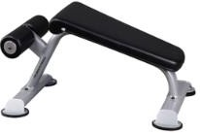 | DIMENSIONS (±10%)  LENGTH: 60 CM  WIDTH: 50 CM  HEIGHT: 75 CM | DESCRIPTION:  - DURABLE ABDOMINAL BENCH FOR GYM USE  - SEATING AND LAYING DOWN AREAS TO BE CUSHIONED AND COVERED BY LEATHER-LIKE MATERIAL.

- EXERCISE MAT – ESTIMATED QUANTITY: 30

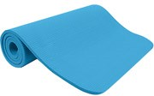 | DIMENSIONS (±10%)  LENGTH: 185 CM  WIDTH: 60 CM  THICKNESS: 1.5 CM | DESCRIPTION:  - DURABLE EXERCISE MAT FOR GYM USE  - LIGHTWEIGHT  - COLD RESISTANT  - WATER REPELLANT  - NONTOXIC MATERIALS AND WASHABLE

- SKIPPING ROPE – ESTIMATED QUANTITY: 15

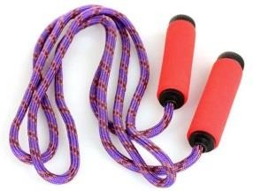 | DIMENSIONS (±10%)  LENGHT: 250 CM | DESCRIPTION:  - DURABLE SKIPPING ROPE FOR GYM USE  - MADE FOR SPEED (5-6 TURNS PER SECOND) AND POWER JUMP ROPE TRAINING.  - COMFORT GRIP HANDLE

- KETTLEBELL – ESTIMATED QUANTITY : 20 sets of all weights

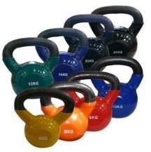 |  | FORMATS DE :  6 KG, 8 KG, 10 KG, 12 KG, 14 KG, 16 KG ET 20 KG

- PRO DUAL COMMERCIAL FOUR WEIGHT STACK MULTI GYM – ESTIMATED QUANTITY: 4

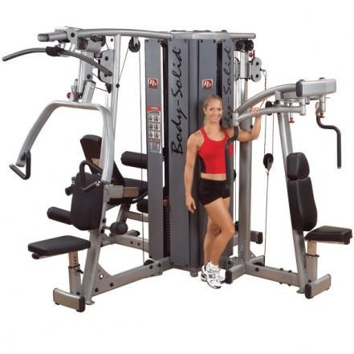 | DIMENSIONS  INSTALLED DIMENSIONS: 96CM(L)X96CM(W)X210CM(H) | DESCRIPTION:  THE PRO DUAL COMMERCIAL FOUR WEIGHT STACK MULTI GYM REVOLUTIONIZES THE COMMERCIAL EQUIPMENT MARKET BY PROVIDING A MODULAR APPROACH TO DESIGNING YOUR NEXT TRAINING FACILITY. THE PRO DUAL LINE OFFERS 10 DUAL FUNCTION STATIONS THAT CAN BE USED IN SINGLE OR MULTIPLE STACK ARRANGEMENTS. THE COMBINATIONS ARE ENDLESS, ALLOWING YOU TO CUSTOMIZE THE EQUIPMENT TO BEST SUIT YOUR TRAINING NEEDS.  THE ANCHOR OF THE MULTI-STATION SYSTEM IS THE 4 STACK WEIGHT TOWER. WITH POSITIONS FOR 4 STATIONS, THE SPACE SAVING 4 STACK TOWER PROVIDES A SOLID FOUNDATION FOR ANY OF THE 10 DIFFERENT PRO DUAL STATIONS.  - 4 INDEPENDENT WEIGHT STATIONS.  - 4 UNIVERSAL UPPER AND LOWER STATION MOUNTS  - 4 UNIVERSAL UPPER AND LOWER PULLEY STATIONS  - 4 EASY MOUNT CHROME GUIDE RODS  - 210LB. / 95KG WEIGHT STACKS (X4)  FEATURES:  BUILD ANY COMBINATION OF PRO-DUAL EQUIPMENT FOR THE PERFECT SOLUTION TO YOUR FITNESS NEEDS. 10 WORKOUT STATIONS ALLOW YOU TO CUSTOM BUILD THE PERFECT GYM SYSTEM.  NB – ADD ANY 4 OF THE FOLLOWING STATIONS TO THE 4 STACK WEIGHT TOWER:  - VERTICAL PRESS & LAT STATION  - CABLE COLUMN STATION  - PEC & REAR DELTOID STATION  - LEG EXTENSION & CURL STATION

- AB & BACK STATION
- CHEST & SHOULDER PRESS STATION
- LEG & CALF PRESS STATION
- INNER & OUTER THIGH STATION
- LAT PULLDOWN & MID ROW STATION
- BICEP & TRICEP STATION

- MULTI GYM STATION – ESTIMATED QUANTITY: 4

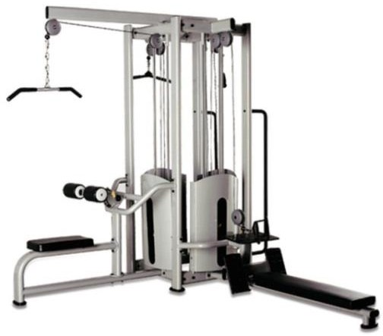 | DIMENSIONS (±10%)  LENGTH: 200 CM  WIDTH: 280 CM  HEIGHT: 250 CM | DESCRIPTION:  - DURABLE INDOOR MULTI GYM STATION FOR GYM USE, ALLOWING A FULL BODY WORK OUT.  - EXERCISES:  O CHEST PRESS  O CHEST SUPPORTED MID ROW  O LEG EXTENSION  O LEG PRESS  O BICEPS  O BUTTERFLY  O PULLING  O LOW PULLEY  O MID PULLEY  O SHOULDER PRESS AND CALF RAISE  - SEATING AND LAYING DOWN AREAS TO BE CUSHIONED AND COVERED BY LEATHER-LIKE MATERIAL.

- DUMBBELL STAND (RACK) – ESTIMATED QUANTITY: 10

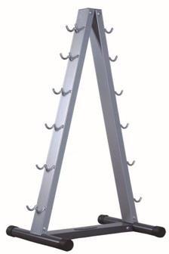 | DIMENSIONS (±10%)  LENGTH: 70 CM  WIDTH: 30 CM  HEIGHT: 100 CM | DESCRIPTION:  - DURABLE DUMBBELL STAND (RACK) FOR GYM USE  - TWO TIERS VERTICAL DUMBBELL RACKS ABLE TO HOLD TWO PAIRS OF DUMBBELLS.  - SHOULD HOLD UPTO 100 KG TOTAL WEIGHT.

- DUMBBELL SET – ESTIMATED QUANTITY: 20 sets of all weights

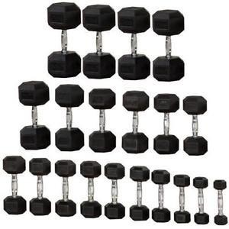 | DIMENSIONS:  VARIOUS | DESCRIPTION:  - DURABLE COMPLETE DUMBBELL SET FOR GYM USE  - INCLUDED DUMBBELL WEIGHTS:  O 2.5 KG X 2  O 5 KG X 2  O 7.5 KG X 2  O 10 KG X 2  O 12.5 KG X 2  O 15 KG X 2  O 17.5 KG X 2  O 20 KG X 2  - ONE PAIR OF DUMBBELLS WILL BE DELIVERED FOR EACH WEIGHT LISTED ABOVE.  - DUMBBELLS COVERED WITH DURABLE PLASTIC TO AVOID DAMAGES  TO FLOOR.

- HORIZONTAL BIKE MACHINE – ESTIMATED QUANTITY: 10

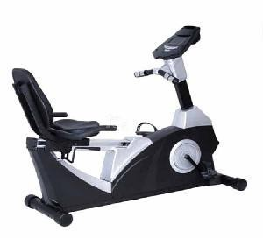 | DIMENSIONS (±10%)  LENGTH: 220 CM  WIDTH: 80 CM  HEIGHT: 210 CM | DESCRIPTION:  - DURABLE HORIZONTAL BIKE MACHINE FOR GYM USE  - DUAL SIDED PEDALS FOR EASE  - RESISTANCE SYSTEM:  O DRIVE SYSTEM, MULTI STAGE  O BELT DRIVE  O MULTI RESISTANCE LEVELS  - CONSOLE SCREEN FEATURES:  O LED  O CONTAINS PRESET PROGRAMS  O NUMERIC KEYPAD  O HEART RATE MONITORING  O ELECTRONIC READOUTS  O MOTION CONTROL

- VERTICAL BICYCLE MACHINE (UPRIGHT BIKE) – ESTIMATED QUANTITY: 10

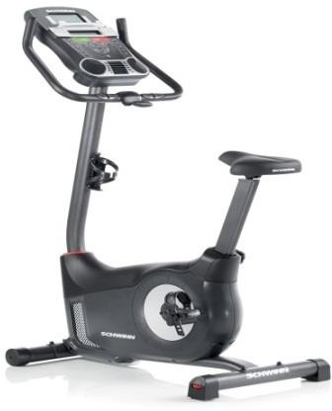 | DIMENSIONS (±10%)  LENGTH: 160 CM  WIDTH: 75 CM  HEIGHT: 140 CM | DESCRIPTION:  - DURABLE INDOOR VERTICAL BICYCLE MACHINE FOR GYM USE  - SEAT SYSTEM: MULTIPLE LEVELS.  - DUAL SIDED PEDALS FOR EASE  - RESISTANCE SYSTEM:  O DRIVE SYSTEM, MULTI STAGE  O BELT DRIVE  O MULTI RESISTANCE LEVELS  - CONSOLE SCREEN FEATURES:  O LED  O CONTAINS PRESET PROGRAMS  O NUMERIC KEYPAD  O HEART RATE MONITORING  O ELECTRONIC READOUTS  O MOTION CONTROL

- ELLIPTICAL BICYCLE MACHINE – ESTIMATED QUANTITY: 10

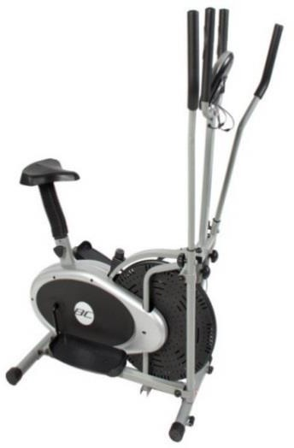 | DIMENSIONS (±10%)  LENGTH: 220 CM  WIDTH: 80 CM  HEIGHT: 210 CM | DESCRIPTION:  - DURABLE INDOOR ELLIPTICAL MACHINE FOR GYM USE  - SEAT SYSTEM: MULTIPLE LEVELS.  - RAMP ANGLE: 10 – 35 DEGREE.  - RESISTANCE SYSTEM: MULTI LEVELS ELECTROMAGNETISM RESISTANCE SYSTEM.  - CONSOLE SCREEN FEATURES:  O LED  O CONTAINS PRESET PROGRAMS  O NUMERIC KEYPAD  O HEART RATE MONITORING  O ELECTRONIC READOUTS  O MOTION CONTROL

- AB ROLLER ESTIMATED QUANTITY: 20

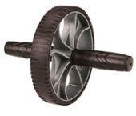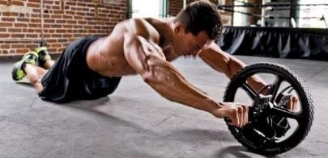 |  | DESCRIPTION :  ROUE DE ROULEAU EST CONÇU POUR AMELIORER LA FORCE ET LA DEFINITION DE VOTRE ABS, LE DOS, LES BRAS ET LES MUSCLES DES EPAULES POUR BRULER LES CALORIES EXCEDENTAIRES.  FACILE A UTILISER A LA MAISON, OU L'EMPORTER AVEC VOUS A LA SALLE DE SPORT OU POUR UNE SEANCE D'ENTRAINEMENT N'IMPORTE OU.  FORME ERGONOMIQUE, ASSURER LE CONFORT ET UNE BONNE PRISE SUR LA ROUE DE ROULEAU, ASSURANT LA STABILITE LORS DE SON UTILISATION EASY-GLIDE HAUTE QUALITE ROUES ROULENT A REDUIRE L'OSCILLATION DES ROUES ET DE VOUS AIDER A CONTROLER VOTRE ENTRAINEMENT  FACILE A UTILISER, SIMPLE MOUVEMENT EN AVANT ET EN ARRIERE, PAS D'APPRENTISSAGE COMPLEXE D'UTILISER CETTE ROUE

- MOTORIZED TREADMILL MACHINE – ESTIMATED QUANTITY: 10

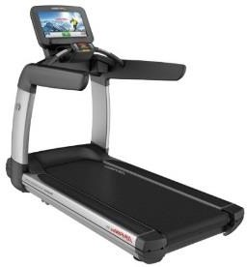 | DIMENSIONS (±10%)  LENGTH: 250 CM  WIDTH: 100 CM  HEIGHT: 70 CM | DESCRIPTION:  - DURABLE INDOOR TREADMILL MACHINE FOR GYM USE  - SPEED RANGE: 1-20 KM/H  - DECLINE / INCLINE RANGE: 0% - 15%  - RUNNING SURFACE (W*L): 50 * 150 CM  - MIN 10 PRESET PROGRAMS INCLUDING:  O MANUAL  O WEIGHT LOSS  O BODY FAT INPUT  O AGE INPUT  - OPTIONS:  O ADJUSTABLE SPEED AND INCLINATION  O HEART RATE READING  O EMERGENCY STOP WIRE POWER REQUIREMENTS:  COMPATIBLE WITH TURKEY POWER GRID REQUIREMENTS (220V / 50 HERTZ).

- PLAQUE DE TORSION - ESTIMATED QUANTITY: 5

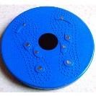

- CONFIDENCE FITNESS SLIM FULL BODY VIBRATION PLATFORM FITNESS MACHINE, BLACK – ESTIMATED QUANTITY: 5

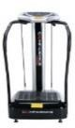

- RAMEUR COVE – ESTIMATED QUANTITY: 5

